# What is Statistical Process Control (SPC)

SPC methodology provides a philosophy and framework for continually learning about the behaviour of processes for analytical purposes - where the aim is to act on the underlying causes of variation to maintain or improve the performance of a process. This is useful, since the ultimate purpose of collecting and analysing data is to support better decision-making and actions that will lead to improvement. SPC is a proven methodology for doing just that. SPC was initially developed by Walter A. Shewhart in the 1920s to improve the quality of manufactured products and has since been successfully used in many settings including healthcare. At is core, SPC methodology involves the plotting of data over time to detect unusual patterns or variations that might indicate a change/problem with a process. This simple graphical device (shown later) is underpinned by an intuitive theory of variation, the hypothesis-generating-testing cycle of the scientific method and statistical theory.

To understand SPC, we first need to understand the theory of variation on which it is based, which we demonstrate below.

# Understanding variation

Consider writing the letter 'a' by hand with a pen and paper. The left panel in Figure 1 displays seven instances of this letter produced by one of the authors.

|  |  |
| --- | --- |
|  |  |

*Figure 1 Handwritten ‘a’s*

Although the letters in the left panel were produced under identical conditions - same hand, date, time, place, pen, paper, temperature, lighting, and other factors—they are not identical. Instead, they exhibit controlled variation. This illustrates that a stable process inherently produces some degree of variation or 'noise'. In analysing this controlled variation, it might be tempting to classify some 'a's as better or worse than their peers, and so attempt to learn from the best while eliminating the worst. However, this approach is fundamentally flawed. Since all 'a's were produced under identical conditions, no single 'a' is inherently better or worse than the others. From the viewpoint of the underlying process, all seven letters are equivalent because they were produced under the same conditions. The variation observed among them has a **common cause** which is inherent in the process itself. So how can we improve these ‘a’s? To improve the quality of the letters we should focus on modifying the process rather than trying to draw lessons from the differences between individual letters.

To reduce variation and improve the quality of the letter 'a', we might consider changes such as using a different pen, paper, or surface, or switching to a computer. Of these options, it is intuitive that using a computer will yield the most significant improvements. This insight is supported by the theory of constraints, which views a process as a chain of interconnected links. The strength of the entire chain is limited by its weakest link. Improving this weakest link will enhance the overall performance, while changes to other, non-constraint links offer minimal benefit. In the context of handwriting, the weakest link is the manual use of the hand. The pen, paper, and lighting are not constraints in this process; altering them will not substantially impact the quality of the 'a'. Switching to a computer addresses the key constraint —handwriting— resulting in a marked improvement in the quality of the letter.

Now consider the ‘a’ in the right panel of Figure 1. It is obviously different from the others. A casual look suggests that there must be a **special cause**. In this case, the author produced the letter using his non-dominant (left) hand. So, when we see special cause variation, we need to find the underlying special cause and then decide how to act. In other words, special cause variation requires detective work. If the special cause is having an adverse impact on our process, we must work towards eliminating it from the process. But if the special cause is having a favourable impact on our process, we can work towards learning from it and making it part of our process.

In summary then, the handwritten ‘a’s demonstrate that a process exhibits two types of variation – common cause and special cause – and the action required to address each type of cause is fundamentally different. To address common cause variation, we must take action on a major portion of the process. To address special cause variation, we must first do some detective work to find the cause and then we can decide to eradicate that cause (if it is unfavourable) or keep it (if it is favourable).

The originator of this theory of variation was Walter A. Shewhart, who in the 1920’s was seeking to enhance the quality of industrial products. Shewhart identified that quality is not just about meeting target specifications but involves managing variation. He distinguished between two types of variation: common cause variation, which is inherent in the underlying process, and special cause variation, which arises from external factors.

There are various characteristics and descriptions of common and special cause variation which are highlighted below.

|  |  |
| --- | --- |
| **Common Cause Variation** | **Special Cause Variation** |
| Is caused by a stable process (like writing a signature) and is intrinsic to the process. | Is caused by an assignable cause that it extrinsic to the process. |
| Is neither good or bad, it just is. | Can be favourable or unfavourable and premediated (as part of an improvement project) or incidental (not part of an improvement project) |
| Can be reduced (but not eliminated) by changing the underlying process. Such changes can be informed by special cause variation. | Unfavourable special cause can be eliminated. Favourable special cause can be adopted and adapted into a new process. |
| Is sometimes referred to as random variation, chance variation, or noise. | Is sometimes referred to a systematic, non-random variation. |
| Depicts the voice or behaviour of a stable process and affects all those who are part of the process. | Is a distinct signal which differs from the usual voice or noise of the process which requires further detective work to identify the assignable cause. |

*Table 1 Characteristics of common versus special cause variation*

# Understanding statistical process control

So now that we have seen an intuitive demonstration of common and special cause variation using the letter 'a', how can we use these ideas in practice with a data from a process in healthcare? In practice this involves the production of SPC chart that depicts the voice or behaviour of a process over time and with the aid of statistical theory, shows if the process is consistent with common or special cause variation. Such charts are known as SPC charts, control charts or process behaviour charts. Scores of control charts exist (which are covered in Part 2). For now, we use one popular chart – known as the i-chart, which is used to plot individual data points over time.

Consider the systolic blood pressure data from a hypertensive patient taken over 26 consecutive days at home before starting any antihypertensive medication shown in Figure 2. These data are plotted on an i-chart with three additional lines – a central line (which is the mean), and upper and lower lines known as control limits (which are set +/- 3 standard deviations from the mean). [In part 2 we will show you how to produce such SPC charts]. Points outside the control limits are a signal of special cause variation. In Figure 2, we can see on data point below the lower control limit which merits detective work to identify the underlying cause.

|  |
| --- |
|  |
|  |

*Figure 2 I-chart of the blood pressure readings of a hypertensive patient.*

SPC charts are operational definitions for identifying common and special cause variation in practice. An operational definition is one which is designed to be practical and useful and leads to agreement between two different people. Special cause variation is associated with signals on a control chart, whereas common cause variation is simply "noise". The absence of signals of special cause variation is evidence that the behaviour of the process is consistent with common cause variation. The presence of signals – such as points outside the control limits – is consistent with special cause variation. In part 2 of the book, we will show you how to produce such charts and provide further details on the rules for identifying signals of special causes of variation.

# SPC in healthcare

In healthcare, SPC methodology is used in two main ways:

* Monitoring the behaviour or performance of an existing process (e.g. complications following surgery), or
* Improving an existing process (e.g. redesigning the pathway for patients with fractured hips).

## Using SPC to monitor a process

In the monitoring mode, the primary aim is to determine if a process is deteriorating which is usually indicated by signals of special cause variation where detective work is undertaken to find the cause and then eliminate it. Such detective work can be undertaken by using the Pyramid Model of Investigation describe below.

### Pyramid model of investigation

The key aim of using statistical process control charts to monitor healthcare processes is to ensure that quality and safety of care are adequate and not deteriorating. So when a signal of special cause variation is seen on a control chart monitoring a given outcome (e.g. mortality rates following surgery), investigation is necessary. However, the chosen method must recognise that the link between recorded outcomes and quality of care ‘…is complex, ambiguous and subject to multiple explanations’22. Failure to do so may inadvertently contribute to premature conclusions and a blame culture that undermines the engagement of clinical staff and the credibility of statistical process control. . As Rogers et al.[ref] note:

*If monitoring schemes are to be accepted by those whose outcomes are being assessed, an atmosphere of constructive evaluation, not ‘blaming’ or ‘naming and shaming’, is essential as apparent poor performance could arise for a number of reasons that should be explored systematically.*

To address this need, Mohammed et al. propose the Pyramid Model for Investigation Special Cause Variation in healthcare – a systematic approach of hypothesis generation and testing based on five a priori candidate explanations for special cause variation: data, patient casemix, structure/resources, process of care, and carer(s).

These broad categories of candidate explanations are arranged from most likely (data) to least likely (carers), so offering a road map for the investigation that begins at the base of the pyramid and stops at the level that provides a credible, evidence-based explanation for the special cause. The first two layers of the model (data and casemix factors) provide a check on the validity of the data and casemix-adjusted analyses, whereas the remaining upper layers focus more on quality of care related issues.

A proper investigation requires a team of people with expertise in each of the layers. Such a team is also likely to include those staff whose outcomes or data are being investigated, so that their insights and expertise can inform the investigation while also ensuring their buy-in to the investigation process. Basic steps for using the model are shown below.

1. Form a multidisciplinary team that has expertise in each layer of the pyramid, with a decision-making process that allows them to judge the extent to which a credible cause or explanation has been found, based on hypothesis generation and testing.
2. Candidate hypotheses are generated and tested starting from the lowest level of the Pyramid Model and proceeding to upper levels only if the preceding levels provide no adequate explanation for the special cause.
3. A credible cause requires quantitative and qualitative evidence, which is used by the team to test hypotheses and reach closure. If no credible explanation can be found, then the only plausible conclusion is that signal itself was a false signal.

The types of questions that can be asked when undertaking the detective work are highlighted below.

|  |  |  |
| --- | --- | --- |
| Level | Scope | Typical questions |
| Data | Data quality issues (e.g. coding accuracy, reliability of charts, definitions, and completeness). | * Are the data coded correctly? * Has there been a change in data coding practices (e.g. are there less experienced coders)? * Is clinical documentation clear, complete, and consistent? |
| Case mix | Although differences in case mix are accounted for in the calculation, it is possible that some residual confounding may remain. | * Are there factors peculiar to this hospital not taken into account in the risk adjustment? * Has the pattern of referrals to this hospital changed (in a way not considered in risk adjustment)? |
| Structure or resource | Availability of beds, staff, and medical equipment; institutional processes. | * Has there been a change in the distribution of patients in the hospital, with more patients in this specialty spread throughout the hospital rather than concentrated in a particular unit? |
| Process of care | Medical treatments of patients, clinical pathways, patient admission and discharge hospital policies. | * Has there been a change in the care being provided? * Have new treatment guidelines been introduced? |
| Professional staff/carers | Practice and treatment methods, etc. | * Has there been a change in staffing for treatment of patients? * Has a key staff member gained additional training and introduced a new method that has led to improved outcomes? |

## Using SPC to improve a process

SPC is also used to support efforts to improve a process. In healthcare, this usually involves making small scale changes and measuring their impact on an SPC chart. In the improving mode, the primary aim is to determine if changes made to a process have been successful (or not). For example, in the handwriting process considered earlier, do we get better ‘a’s after switching to a computer. This is determined by looking to see the impact of the change in the form of signals of special cause variation on a SPC chart. The degree of alignment between changes to the process and subsequent signals of special cause variation provide a story which qualitatively and quantitatively describes the impact of changes.

Common cause variation can only be addressed by changing a major portion of the process. What do we mean by a major portion? The theory of constraints offers the analogy of a chain to demonstrate that the strength of the chain is determined by the weakest link. If we increase the strength of the weakest link the whole chain is strengthened. If we increase the strength of other links but not the weakest link, then the chain does not get stronger. The weakest link is the constraint on the performance of the system, and it is argued that in real systems there are usually only a few, perhaps one or two, constraining factors, all other factors are non-constraints (as demonstrated by the handwriting example earlier). [ref]

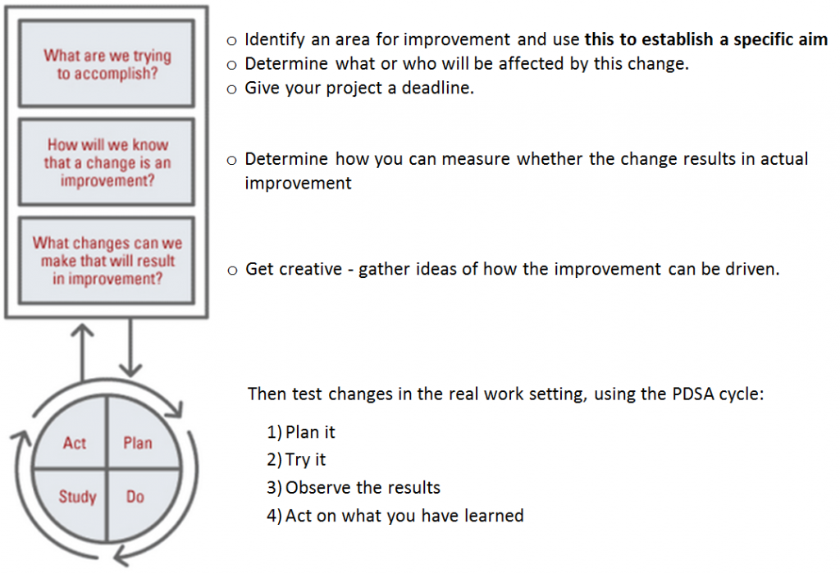The IHI Model for Improvement [ref] is a widely used framework in healthcare to guide improvement efforts. It consists of three fundamental questions and the Plan-Do-Study-Act (PDSA) cycle.

The Three Key Questions

1. What are we trying to accomplish?

This question defines the aim of the improvement effort, which should be specific, measurable, and time-bound along with a rationale for why this is important.

2. How will we know that a change is an improvement?

This question focuses on measurement. The team identifies key performance indicators and other metrics to assess whether the change has led to improvement. This includes balancing measures designed to capture unintended negative consequences from changing a system or process.

3. What changes can we make that will result in improvement?

This question explores potential change ideas or interventions that could lead to the desired improvement which are undertaken according to the PDSA Cycle – which is a method for testing changes on a small scale:

- Plan: Develop a plan to test the change, including who, what, when, and where.

- Do: Implement the change on a small scale.

- Study: Analyze the results, focusing on the impact of the change.

- Act: Decide whether to adopt, modify, or abandon the change based on the results.

There are other approaches to improvement in healthcare, such as lean methodology [ref] and a systems engineering approach [ref[. The SPC chart can support each of these approaches because it offers a robust and insightful way to test the success or otherwise change ideas.

## Successful use of SPC in healthcare

The successful use of SPC in healthcare requires a number of factors which is more than the production of an SPC chart especially in complex adaptive systems like healthcare. These factors include:- engaging the stakeholders; forming a team; defining the aim; selecting the process of interest; defining the metrics of interest; ensuring that data can be reliably measured, collected and fed back; and establishing baseline performance – all in a culture of continual learning and improvement that is supported by the leadership team. To see examples of SPC in action in healthcare, please see [ref@ Mohammed 2024].

Nevertheless, it is important to note that SPC charts are not necessarily easy to construct. After examining 64 statistical process control charts, Koetsier et al. found that that almost half the charts had technical problems which suggests a need for more training for those constructing charts – which is the primary motivation for this book.

In the next chapter we introduce the most frequently used SPC charts and in Part 2 of the book we show you how to produce SPC charts using R.